Web
Lab 12
Name : umar ahad uddin ahmed usmani
Sap : 60199

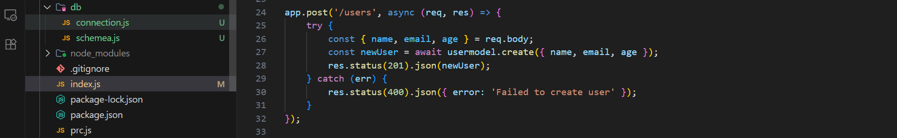
const express = require('express');
import connection from './db/connection';

const app = express();
app.use(express.json());
connection();
const userSchema = new mongoose.Schema({
name: String,
email: String,
age: Number
});

const usermodel = mongoose.model('User', userSchema);

app.get('/users', async (req, res) => {
try {
const users = await usermodel.find({});
res.status(200).json(users);
} catch (err) {
res.status(500).json({ error: 'Failed to fetch users' });
}
});

app.post('/users', async (req, res) => {
try {
const { name, email, age } = req.body;
const newUser = await usermodel.create({ name, email, age });
res.status(201).json(newUser);
} catch (err) {
res.status(400).json({ error: 'Failed to create user' });
}
});

app.put('/users/:id', async (req, res) => {
try {
const { name, email, age } = req.body;
const updatedUser = await usermodel.findByIdAndUpdate(
req.params.id,
{ name, email, age },
{ new: true }
);
if (!updatedUser) {
return res.status(404).json({ error: 'User not found' });
}
res.status(200).json(updatedUser);
} catch (err) {
res.status(400).json({ error: 'Failed to update user' });
}
});

app.delete('/users/:id', async (req, res) => {
try {
const deletedUser = await usermodel.findByIdAndDelete(req.params.id);
if (!deletedUser) {
return res.status(404).json({ error: 'User not found' });
}
res.status(200).json({ message: 'User deleted successfully' });
} catch (err) {
res.status(400).json({ error: 'Failed to delete user' });
}
});

app.listen(3000, () => {
console.log('Server is running on port 3000');
});

Schema
import mongoose from "mongoose";

constProductSchema = new mongoose.Schema({
name: String,
price: Number,
description: String,
inStock: Boolean
});
const ProductModel = mongoose.model('Product', ProductProductSchema);
export default ProductModel;
export { ProductSchema };

